1. Junit 5  
   unit testing might be a specific method or a set of methods  
   Junit 5 annotations:  
   @BeforeAll  
   @BeforeEach  
   @Test  
   @ParameterizedTest  
   @Tag  
   @Repeated  
   @ExtendWith  
   @Disabled  
   @NestedWith  
   @AfterEach  
   @AfterAll  
   @TestFactory  
   @TestInstance  
   @TestTemplate  
   @DisplayName
2. 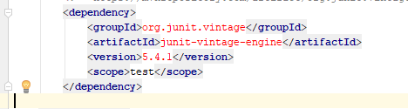  
   Used to run junit 3, junit4 tests using above dependency
3. 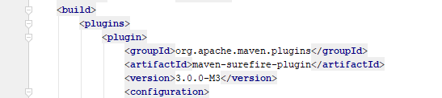  
   maven surefire plugin for test execution
4. 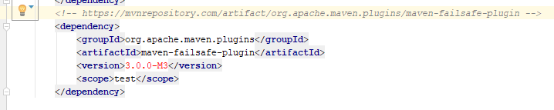  
   Failsafe plugin is used for integration test phase
5. Junit assertions:  
   assertEquals()  
   assertNotEquals()  
   assertTrue()  
   assertFalse()  
   assertNull()  
   assertNotNull()  
   false()  
   assertAll()  
   assertTimeout()
6. Stub is a dummy implementation of the interface
7. Mockito is a popular mocking framework
8. When(someClass.method).thenReturn()  
   when(someClass.method).thenThrow()
9. Mocks are alternatives to real objects and its implementations
10. Mocks type  
    a) Dummy -> object used to get code to compile  
    b) Fake  
    c) Stub -> predefined answers to method calls  
    d) Mock -> can throw exceptions  
    e) Spy -> wrapper around actual object
11. Mockito annotations:  
    @Spy  
    @Mock  
    @InjectMocks  
    @Captor